**Continuing Hotel Sales CRM system**

**for National Select Service Hotel Chain**



**Consultants:**

Akshay Gupta, Joshua Meyer

**Consulting Firm:**

Apoco Designs



**Client Information**

**Client Organization:** La Quinta Inn and Suites Stillwater

**Main Contact:** Dean Schrock

**Contact Position:** General Manager La Quinta Stillwater  
**Address:** 5285 W 6th Ave, Stillwater, OK 74074

**Phone:** 405-564-0599

**Vocabulary**

**LNR:** local negotiated rate. These are rates that are negotiated between an organization or company and the hotel. Basically the organization get a discount on hotel rooms because they bring X number of rooms per year to the hotel.

**Group Rate:** These are discounted rates when an organization need a large number of rooms over certain dates. Wedding blocks are typical example along with church retreats etc.

**PMS:** property management system. This is the on property information system for the hotel which is in charge of room management, reservations, accounting, and billing.

**CRS:** Central Reservation System. This is a system that a hotel brand uses that takes reservations from the hotel’s website, call centers and usually interfaces with other CRS and GDS systems then transfers that information to an individual hotel’s PMS system. The CRS is a middleman between GDS or customers and the PMS system.

**GDS:** global distribution system. This is another middle man that is hotel and hotel brand agnostic and many travel agents 3rd party bookings are made through a global distribution system which interfaces with a brand CRS system which then transfers the information to the hotel’s PMS system.

**Consultant Introductions**

Apoco Designs is a new software consulting firm that provides software design and hospitality consulting services to a variety of businesses in accommodation, restaurant and gaming industries. We specialize in consulting with clients on process redesign, customer satisfaction and hospitality specific software. The team is headed by Joshua Meyer who has 10 years of experience in the hospitality industry. He just started his master’s degree in MIS and is excited to be improving hospitality information systems and processes. Josh is going to be acting as Project Owner and Scrum Master for the project because Josh is intimately familiar with the select service hotel chain’s sales processes and current information systems. Akshay Gupta has years of experience in the financial world and recently decided to add software development to his list of skills and is now pursuing a master’s degree in MIS. Akshay brings years of development experience to the consulting team and will be the teams lead developer.

A ROO

**Project Description**

The Hotel CRM development project is a continuing project to design and execute a functional prototype of the core functionality for a new company wide sales CRM system for individual La Quinta Inn and Suites properties. This system is being developed because Joshua Meyer was the Director of Sales at a local La Quinta and found that the brand had no formal on property sales process or information system for maintaining relationships with LNR, Group Block and Meeting Room Rental Clients at the individual property level. After speaking with various GM’s throughout the company and knowing that La Quinta hotel’s are generally operated without dedicated sales staff. This means that the hotel GM or front desk manager is responsible for hotel sales in addition to their hotel operations duties. This means that any time taken to perform sales functions takes away from the managers ability to perform other important operational tasks. Having a CRM system that reduces the amount of time for data entry and retrieval would benefit the company greatly.

Josh first researched and developed a formal sales process that could be followed by all staff at the property. Once that process was developed Josh started looking for ways to automate and streamline the sales process to reduce the amount of redundant data and eliminate the substantial paper trail required for the system comprised of paper and electronic documents. He signed up for a free version of Zoho CRM system but found that the system would not allow him to customize the software without a hefty per month cost to the hotel. Josh then started designing a custom CRM system using various relational database systems including Microsoft Access, SharePoint and MySQL. In the fall of 2017 he lead a group of students to build, document and design a database in MySQL that satisfied the core requirements for a custom La Quinta Specific sales CRM system.

The three primary uses for the new sales CRM system on a property level would be contact, lead and deal: creation, management and tracking. By having a standard CRM and sales process across the brand would streamline individual properties sales efforts, increase the amount of time general managers can spend actually selling vs pushing paper.

Secondary functionality for the new sales CRM system includes integration with various other La Quinta technology systems already in place. This functionality will not be included in the current project but is mentioned because the underlying database was designed to allow for integration with other systems and help with understanding some of the limits of the prototype system. The new sales CRM system will eventually be closely integrated with individual property’s PMS systems and reduce the amount of redundant data entry performed by on premises management and front desk personnel. This integration will allow the new CRM to both pull and push customer, group block, LNR and other pertinent sales data to the property PMS system. The PMS integration is the most important integration for the new CRM system. The system will also integrate and streamline La Quinta’s company sheet process for local negotiated rates, which currently takes up to 3 weeks and is a manual process involving excel spreadsheets. The eventually goal is to have the new CRM system automate the company sheet creation and update process and eventually directly integrate with La Quinta’s CRS, and other GDS systems. Lastly, the CRM system will be integrated with La Quinta corporate Salesforce CRM system. This will allow corporate sales managers to mine individual hotel’s for promising companies that may need to be contacted about brandwide LNR rates. This would get rid of the current Excel document based process were individual properties sales managers and general managers fill out the Excel form and email it to a Corporate Sales worker who then manually sorts through forms and enters promising leads into the Salesforce CRM system.

**Current Issues**

* No standard Sales process across the La Quinta brand
* Stillwater location uses combination of paper document, electronic document and CRM systems for tracking customers through the sales process.
* Communication of sales information is difficult
* Current sales process has multiple instances of redundant data entry
* Company sheet data has 1-3 week lag before the information is updated in La Quinta CRS and various GDS and web databases due to manual electronic document process.
* La Quinta wants every employee to be a salesperson and currently does not provide a great mechanism to communicate and evaluate sales information among hotel employees

**System Benefits**

* Reduced data redundancy
* All employees can be involved in the sales process
* Better communication between sales, front desk and housekeeping pertaining to customer needs.
* Increased sales consistency across the brand

**System Constraints**

* System Cost
* System Training
* System complexity
* Integration with other hotel systems

**Core User Stories**

1. As a **Sales Director** I want to store contact information so that I can keep track of my contacts and their companies. I need contact names, phone numbers, email, physical address, birthdays, anniversaries and place for notes.
2. As **Sales Director** I want to store company information so that I can keep track of my corporate clients and the company contact(s). I need their main phone number fax number, email, website, mailing and billing address and I also need to know what contacts I have that are associated with this company.
3. As **Sales director** I need to be able to create leads from my companies so I can track entities progress through the hotel’s sales cycle.
4. As **Sales director** I need to be able to turn my leads into deals once the lead has been qualified. This is so I can keep track specific customer needs for each deal made and store all information needed to be entered into various hotel systems.
5. As **Sales Director** I need 3 different deal types. This is because customers that have different deals have different needs and those needs have to be entered into different systems. Deal Types are LNR, Group Block and Meeting Room Rental.
6. As **Sales Director** I need to be able to be able to create and manage Meeting Room Rental information so I can set room and offer services that meet client’s needs.
7. As **sales Director** I need all my deals to be able to track forecasted vs actual room pickup.
8. As **Sales Director** I need to be able to granularly create group blocks with a variety of different room types, lengths of stays and pricing to fulfill the needs of various clients and be able to track my sales performance overtime and also forecast revenue and availability.
9. As **Sales Director** I need to be able to quickly set up LNR rates with corporate clients so I can get the rates approved by revenue management and have the rate information added to various PMS, CRS and online systems.
10. As **Front Desk Clerk** I need to be able to create new sales leads so that they can be evaluated by the GM and Sales Director and meet La Quinta’s Everyone Sells goals.
11. As **Front Desk Clerk** I need to be able to view deal data so I can update pertinent systems and fix mistakes in reservation and rental setups in addition to confirming customer needs without needing to consult sales.
12. As **Housekeeping** I need to be able to create new sales leads so that they can be evaluated by the GM and Sales Director and meet La Quinta’s Everyone Sells goals.
13. As **Executive or Assistant Executive Housekeeper** I need to be able to see group stay information so I can schedule housekeepers and meet individual clients housekeeping needs without having to consult with sales staff.
14. As **Maintenance Staff** I need to be able to create new sales leads so that they can be evaluated by the GM and Sales Director and meet La Quinta’s Everyone Sells goals.
15. As **General Manager** I need to see reports on the sales funnel and how much money is in the various stages of leads and deals so that I can see how sales is performing and forecast revenue.
16. As **General Manager** I also need all functions that sales has because as General Manager I am the ultimate on premises authority on sales.
17. As **General manager** I want to have a report that includes all sales calls made on a weekly basis, all new leads that were generated in the week and all new deals that were created in the week and all deals that closed in the week so I can track sales progress and keep track of what sales is doing ensure the sales manager are making the hotel money and are a good investment.
18. As **Front Desk Manager** I also need all functions that sales because I am help with sales and am in charge of interacting with clients. I need to be able to update and correct sales information along with create new contacts, companies, leads and deals while sales is not on property.

**Project Plan**

The project plan is listed below. The project will contain 6 sprints that will vary in length between one and two weeks depending on the planned complexity and quantity of user stories that are to be included in the sprint. While this is not strict adherence to agile policies it allows the developers more flexibility as the developers at Apoco Designs are students and not full time workers. All other project timeline information can be found in the Microsoft Project document.

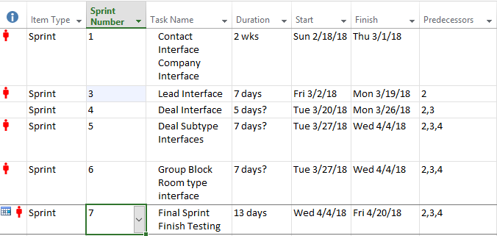

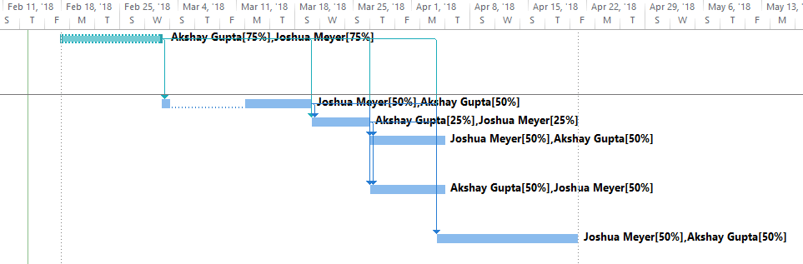

**Statement of Work**

**Objective**

Customer Relationship Management (CRM) not only builds a comprehensive database containing all information pertaining to the customers, but it also facilitates the company’s long term growth by forging strong ties with the customers. The system we are going to build will provide solutions for the problems that current manual system are facing. The aim is to align the CRM system with the organizational goals, to promote customer loyalty and to empower the employees in performing their duties.

**Scope of work**

The project scope is to build a prototype hotel sales CRM system. The database for the system has already been developed by a previous project team and only needs minor revisions. The major goal of the current project group is to build a user interface for the core functionality of the sales CRM database. This includes building the interfaces for the contact, company, lead and deal tables. If time permits additional interfaces will be built for deal subtype tables.

**Requirements**

In terms of functional requirements, the system will have interfaces that enable the users to do the desired work as defined in the core user stories. Following are a few functional requirements for the new CRM system.

I. System will create a lead as soon as a hotel employee enter the details via the website.

II. System will create a new lead which will be displayed as a new lead for Sales Director or General Manager to evaluate.

III. System will record booking information if the guest confirms the booking.

IV. System should archive the booking information even if event, group block or company failed to show up for their reservations. This is to be used for future dealings with the company and provide mining data for corporate sales and marketing.

V. System will allow Sales Director and GM to create and update sales company contact, lead and deal (booking data).

**Period of performance**

The period of performance for the Website Redesign Project is nine weeks beginning on February 14, 2018 through April 21, 2018. All of the work is scheduled to be completed within this time frame.

**Place of performance**

The majority of the work will be done remotely by the Apoco team at its own facility.

Team Apoco will be meeting La Quinta officials at their facility for the weekly status meeting.

**Cost**

* Labor 492 Hours at $25/hr labor cost is $12300.00
* Powerapps software is $7/user/month
* Developers use of Powerapps for 3 months $42
* Cost of the already developed database is unknown but it was provided to Apoco Designs free of charge
* Total cost of development should be around **$12342.00**
* The cost of adoption of Powerapps CRM system would be minimal to La Quinta because Powerapps is already included in their current Office 365 subscription for General Managers and Directors of Sales.

**Deliverable Schedule**

P1 2/14/2018

P2 3/03/2018

P4 4/07/2018

P5 4/21/2018

**Acceptance Criteria**

The Prototype will be accepted if it fulfills all of the user stories and functional requirements outlined except user stories numbered 18, 14, 13, and 12 which are optional and would be nice to add to the prototype. User stories 17 and 15 do not need to be fulfilled and are beyond the scope of the prototype and core functionality of the Sales CRM system.

P2

Executive Summary

Apoco Designs is working with La Quinta Inn and Suites Stillwater on a project to develop a functional prototype for a hotel sales CRM system. The reason for this project is the current CRM system is a combination of paper and electronic documents along with a poorly implemented freeware Zoho CRM system. The Zoho system lacks any hotel specific functionality and is only somewhat helpful for some sales pipelines. The lack of a formal sales system and sales information system has hindered La Quinta’s ability to attract large corporate clientele and also makes it difficult to provide excellent customer service to its clients that book through sales. Apoco Designs was commissioned to build a functional prototype to show management of the La Quinta Stillwater that a custom hotel specific CRM system will improve the sales process, increase group and corporate customer satisfaction and decrease errors caused by the current sales process.

**Revised Current Situation**

The Hotel CRM development project is a continuing project to design and execute a functional prototype of the core functionality for a new company wide sales CRM system for individual La Quinta Inn and Suites properties. This system is being developed because Joshua Meyer was the Director of Sales at a local La Quinta and found that the brand had no formal on property sales process or information system for maintaining relationships with LNR, Group Block and Meeting Room Rental Clients at the individual property level. After speaking with various GM’s throughout the company and knowing that La Quinta hotel’s are generally operated without dedicated sales staff. This means that the hotel GM or front desk manager is responsible for hotel sales in addition to their hotel operations duties. This means that any time taken to perform sales functions takes away from the managers ability to perform other important operational tasks. Having a CRM system that reduces the amount of time for data entry and retrieval would benefit the company greatly.

Josh first researched and developed a formal sales process that could be followed by all staff at the property. Once that process was developed Josh started looking for ways to automate and streamline the sales process to reduce the amount of redundant data and eliminate the substantial paper trail required for the system comprised of paper and electronic documents. He signed up for a free version of Zoho CRM system but found that the system would not allow him to customize the software without a hefty per month cost to the hotel. Josh then started designing a custom CRM system using various relational database systems including Microsoft Access, SharePoint and MySQL. In the fall of 2017 he lead a group of students to build, document and design a database in MySQL that satisfied the core requirements for a custom La Quinta Specific sales CRM system.

The three primary uses for the new sales CRM system on a property level would be contact, lead and deal: creation, management and tracking. By having a standard CRM and sales process across the brand would streamline individual properties sales efforts, increase the amount of time general managers can spend actually selling vs pushing paper.

Secondary functionality for the new sales CRM system includes integration with various other La Quinta technology systems already in place. This functionality will not be included in the current project but is mentioned because the underlying database was designed to allow for integration with other systems and help with understanding some of the limits of the prototype system. The new sales CRM system will eventually be closely integrated with individual property’s PMS systems and reduce the amount of redundant data entry performed by on premises management and front desk personnel. This integration will allow the new CRM to both pull and push customer, group block, LNR and other pertinent sales data to the property PMS system. The PMS integration is the most important integration for the new CRM system. The system will also integrate and streamline La Quinta’s company sheet process for local negotiated rates, which currently takes up to 3 weeks and is a manual process involving excel spreadsheets. The eventually goal is to have the new CRM system automate the company sheet creation and update process and eventually directly integrate with La Quinta’s CRS, and other GDS systems. Lastly, the CRM system will be integrated with La Quinta corporate Salesforce CRM system. This will allow corporate sales managers to mine individual hotel’s for promising companies that may need to be contacted about brand wide LNR rates. This would get rid of the current Excel document based process were individual properties sales managers and general managers fill out the Excel form and email it to a Corporate Sales worker who then manually sorts through forms and enters promising leads into the Salesforce CRM system.

**System Benefits**

* Reduced data redundancy
* All employees can be involved in the sales process
* Better communication between sales, front desk and housekeeping pertaining to customer needs.
* Increased sales consistency across the brand

**System Constraints**

* System Cost
* System Training
* System complexity
* Integration with other hotel systems

**New CRM System implementation problems and Tool Change.**

The initial plan for for the New CRM System was to use the already designed MySQL database and design the user interface and business logic using Microsoft PowerApps. Unfortunately, PowerApps Require a business or school Microsoft 365 membership and Oklahoma State University has revoked students access to PowerApps and La Quinta is unable to provide access to their corporate 365 subscription. This forced the team, to instead choose to use Microsoft Access for the prototyping work sue to the database also being created in the Access and the simplicity of GUI design using Access forms and VBA. The plan is at a minimum to implement a prototype Access application. If time permits the team will attempt to upload the completed access application to a SharePoint server instance which will turn the access application into a web app.

**Problem Analysis**

* No standard Sales process across the La Quinta brand
* Stillwater location uses combination of paper document, electronic document and CRM systems for tracking customers through the sales process.
* Communication of sales information is difficult
* Current sales process has multiple instances of redundant data entry
* Company sheet data has 1-3 week lag before the information is updated in La Quinta CRS and various GDS and web databases due to manual electronic document process.
* La Quinta wants every employee to be a salesperson and currently does not provide a great mechanism to communicate and evaluate sales information among hotel employees

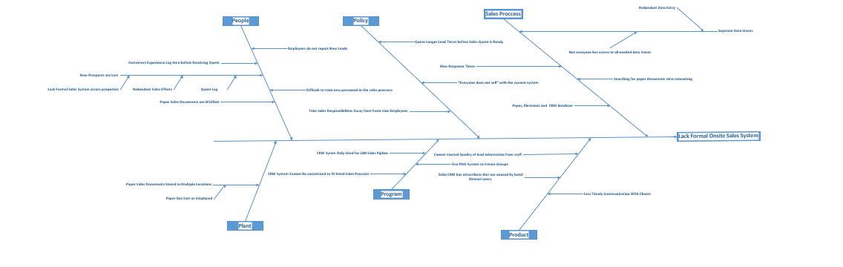

**System Stakeholder Empathy Maps**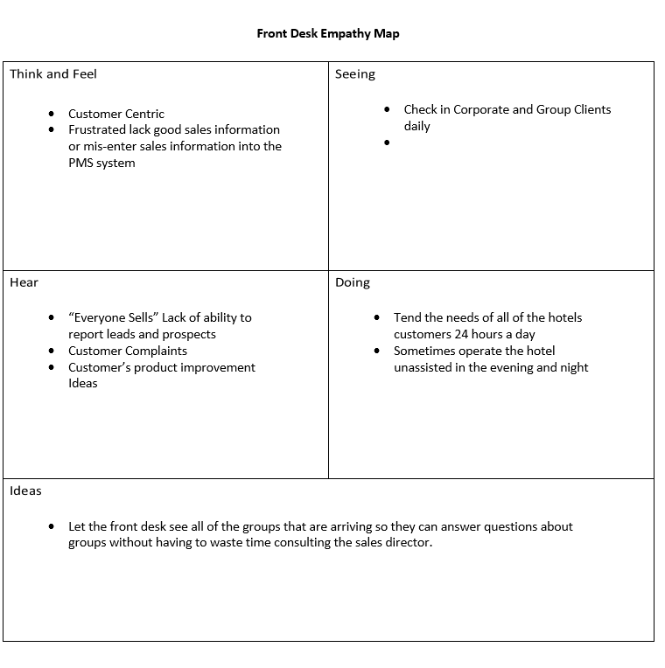 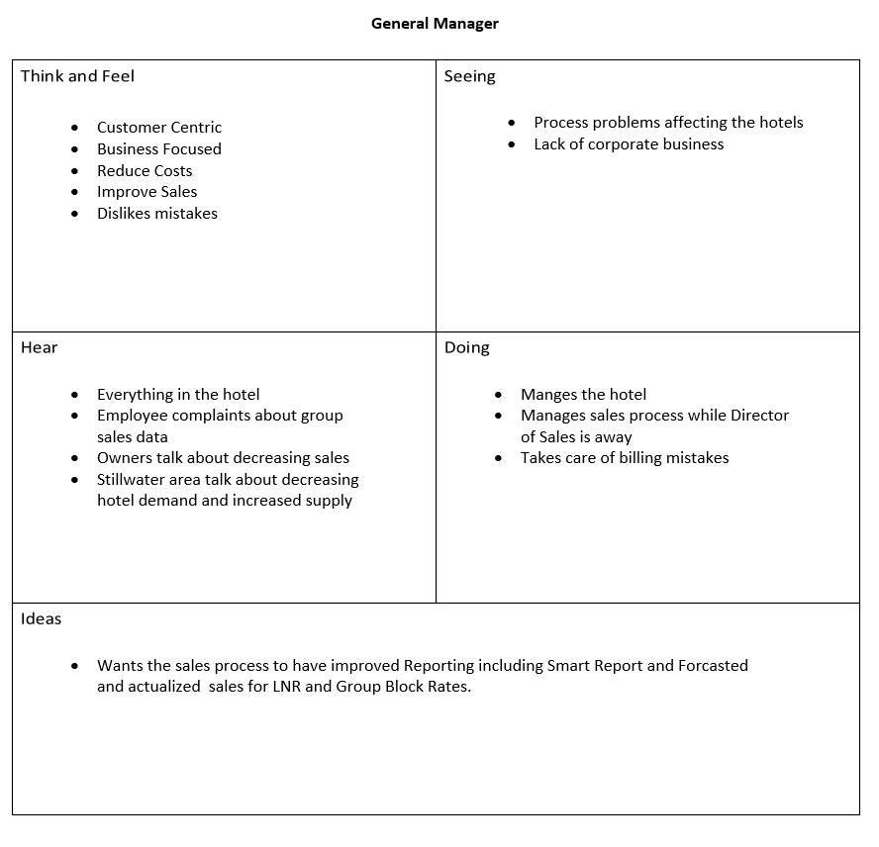 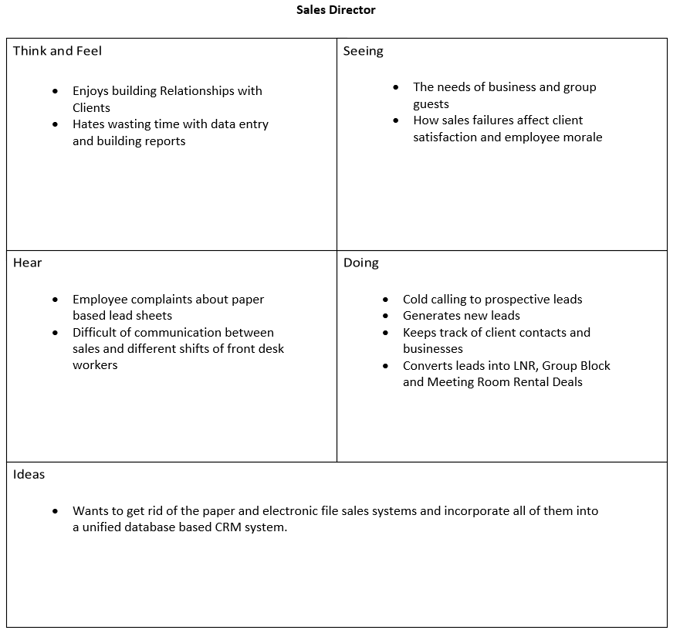 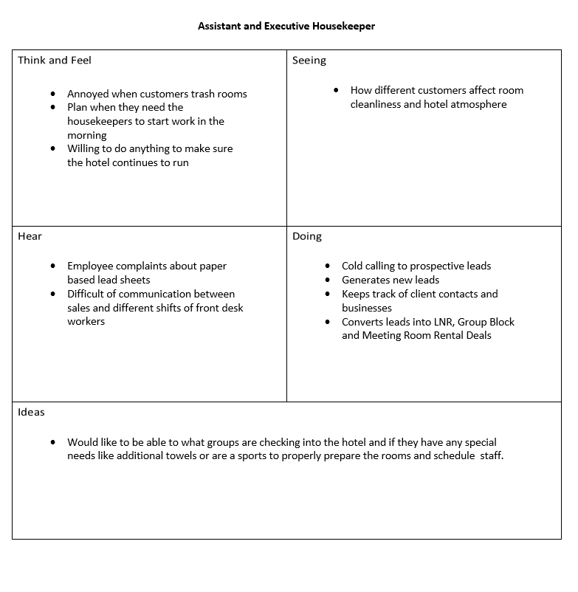 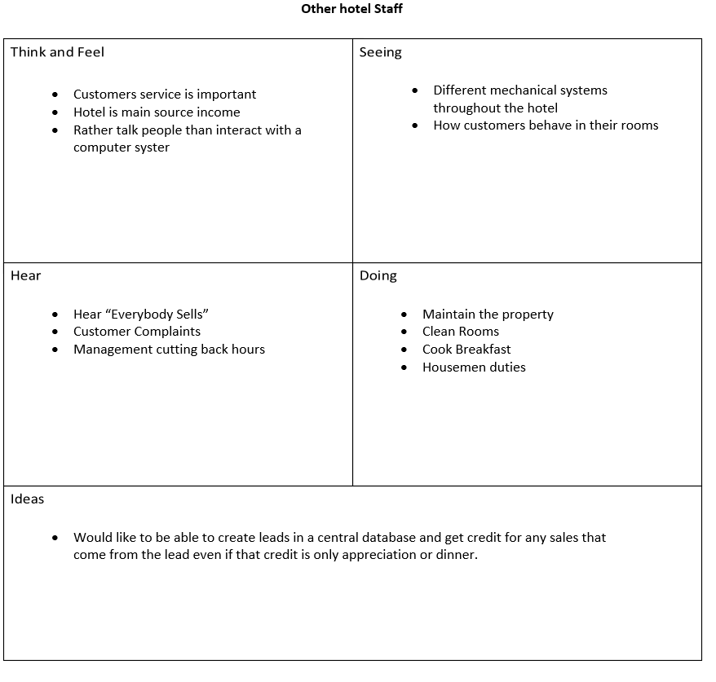 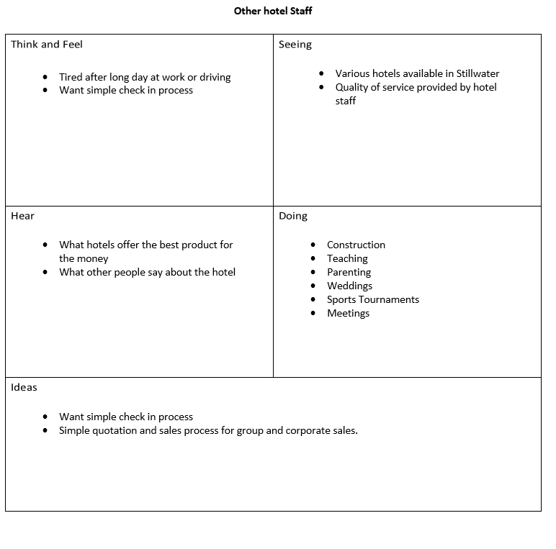

Only internal stakeholders and clients are listed because those are the only clients directly affected by the prototype system.

**System Objectives**

* Remove the redundant data entry from the sales process.
* Remove the need for paper and electronic file sales system
* Improve data consistency by enforcing datatype and Requirement rules
* Reduce the amount of training required to use the sales system
* Reduce the amount of data entry Required by Sales Director and or General manager
* Allow Front desk and Executive and Assistant Executive Housekeeper to view Group block and LNR data
* Improve corporate and LNRs sales by reducing quote times, and standardizing the sales process throughout the brand.

**Running Cost and Cost Estimate of Project**

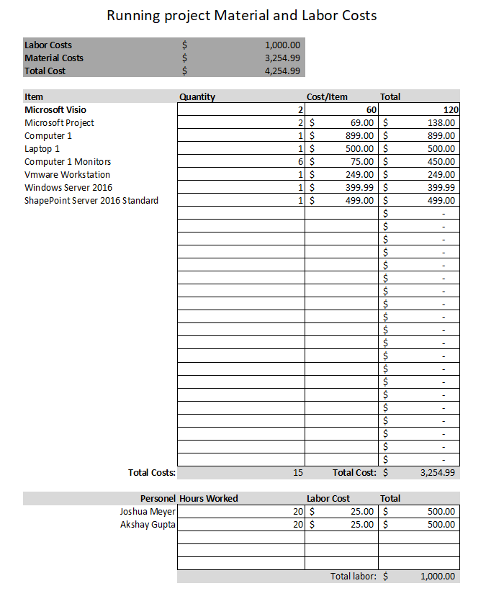

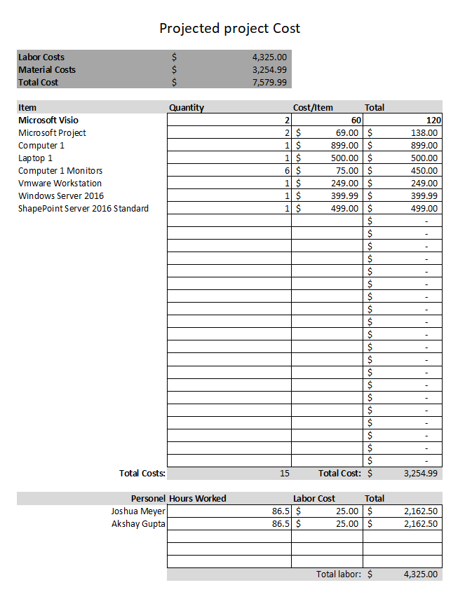

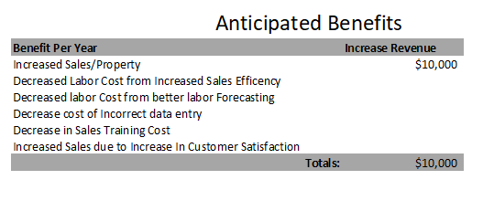

**Resources Needed**

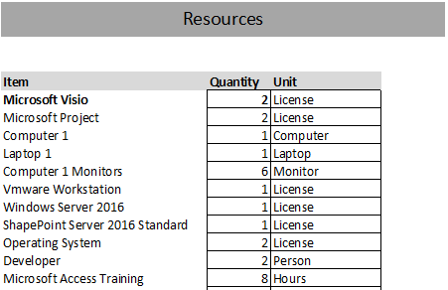

**System Description**

There are thee possible solutions for the sales problems faced by the La Quinta Stillwater. One is Editing a prebuilt sales CRM solution like Salesforce or Zoho CRM, which would reduce development time and development cost. Hower The long term cost of Salseforce and Zoho make them prohibitively expensive because in order to edit the software you must pay around $25-$35 dollars per user which makes it out of the qestion when you want to allow all of the hotel’s employees to have some sort of access to the CRM system. Below is Solution matrix which shows a list of Items that were used to rate each possible solution and are weighted by their imprtance. The highest weight has gone to cost, ease of development and whether the company is already using the software. The reason that these are weighted the highest is because if La Quinta is already paying for Powerapps and Microsoft Access they incur less cost for each implementation of the system. Ease of development was chosen because the project is developing a functional prototype and it is not worth the developers time using a difficult to use development platform. While Powerapps was the overall winner in the solution matrix the developers are unable to use Powerapps due to Apoco’s lack of a corporate or education office 365 subscription that includes PowerApps.

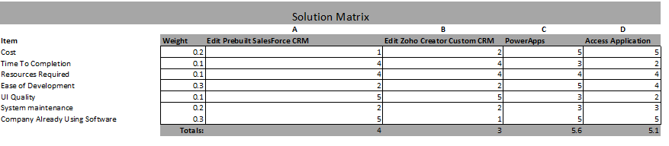

**Technical and Operational Feasibility**

**-Technical Feasibility**

Technical feasibility of the project is high due to the database already being created in both Access and MySQL which means that the underlying structure of the application is already built. Additionally, One of the developers already had some experience in both Access and PowerApps UI Microsoft SharePoint Server so the project should be technically feasible.

**-Operational Feasibility**

The application as designed meets the core user requirements outline in the user stories 18, 14, 13 and 12. As long as the new system follows it design the system should be operationally feasible for the core components of the new prototype CRM system.